Meachem, John Chadwick (based on book by John Meachem (2000) “Finding my self. Memoirs and musings of a forester”)
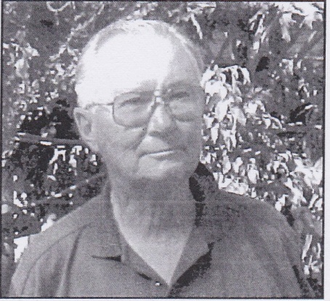
Born 5.12.1919 Perth. Educated at Roleystone Primary school 1928-32, Perth Boys School, in James Street and Perth Modern School 1937-38. At University of W.A. 1938-40, then attended Australian Forestry School in 1941-42, but did not graduate until 1947. Employed by Forests Department at Hoffmans Mill, then Collie. In Royal Australian Air Force 1943-46. Awarded the Distinguished Flying Cross (DFC) in 1946. After the war, worked in Collie and Manjimup. Replaced John d’Espeissis as Divisional Forests Officer in Pemberton in 1951. In Pemberton until 1961. Moved to Manjimup for a year, then to Head Office for 19 years. Initially Regional Superintendent North, then Chief of Division 1965. Retired 15.1.1980, had 42 years with the Forests Department.
Chairman of the W.A. Division of the Institute of Foresters 1974-75. Became a Fellow of the Institute of Foresters in 1983. Member of Freemasons, Bowling Club and Probus Club in Kalamunda 1981-86. Moved to Mandurah area c1993. On the Board of the W.A. Council on the Ageing 1978-87. In 2002, nominated for Senior of the Year.Married Dorothea Gobby, children: Stewart, Candace, Gregory, Rex.

